Assignment 2 : Retrieve data using join with where clause

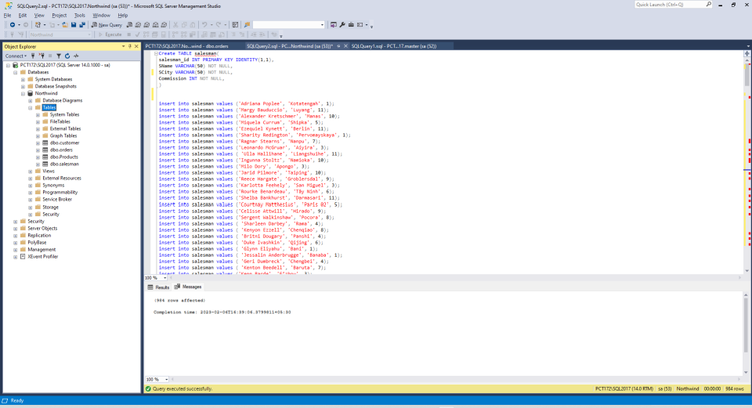

1. write a SQL query to find the salesperson and customer who reside in the same city.
Return Salesman, cust_name and city
---1)
SELECT SName , cust_Name , SCity
FROM salesman
JOIN customer
ON salesman.SCity = customer.city
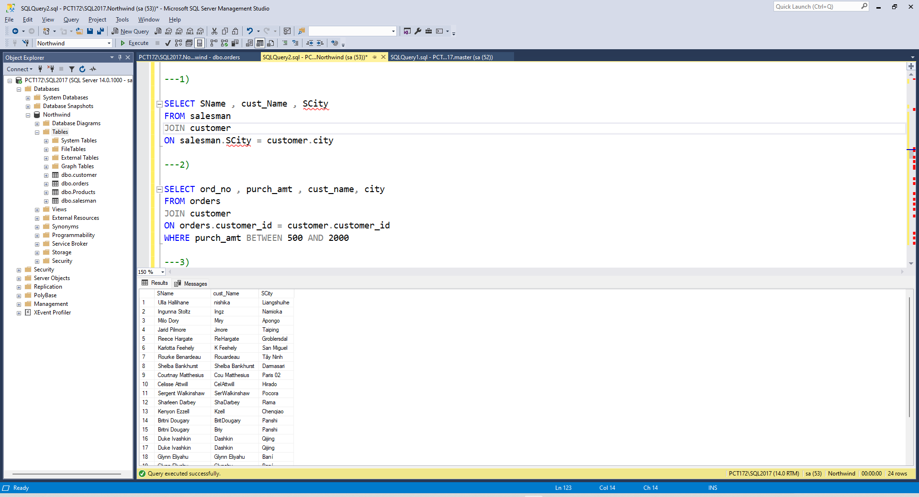
2. write a SQL query to find those orders where the order amount exists between 500
and 2000. Return ord_no, purch_amt, cust_name, city
SELECT ord_no , purch_amt , cust_name, city
FROM orders
JOIN customer
ON orders.customer_id = customer.customer_id
WHERE purch_amt BETWEEN 500 AND 2000

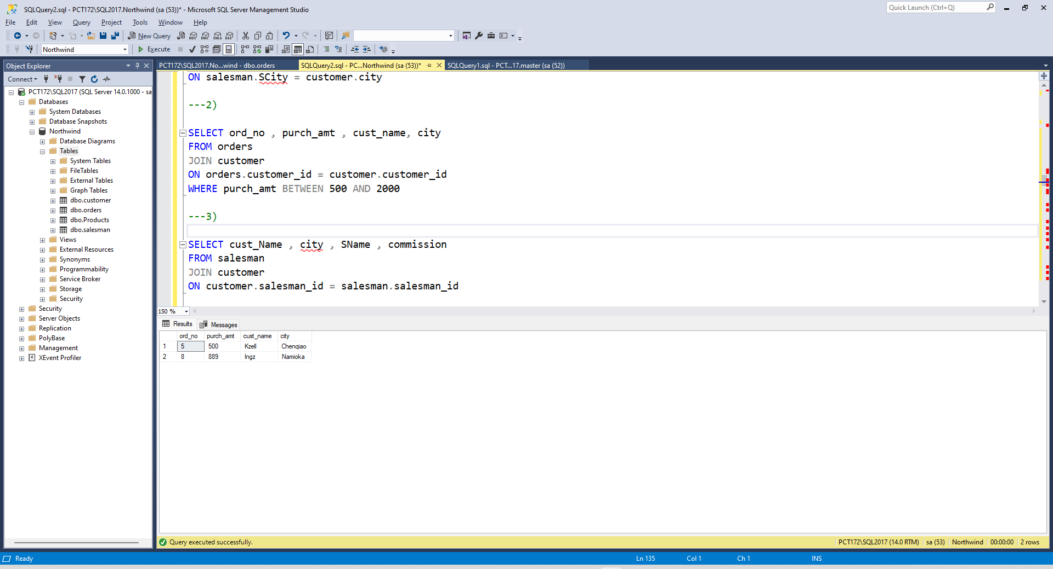
3. write a SQL query to find the salesperson(s) and the customer(s) he represents.
Return Customer Name, city, Salesman, commission
SELECT cust_Name , city , SName , commission
FROM salesman
JOIN customer
ON customer.salesman_id = salesman.salesman_id
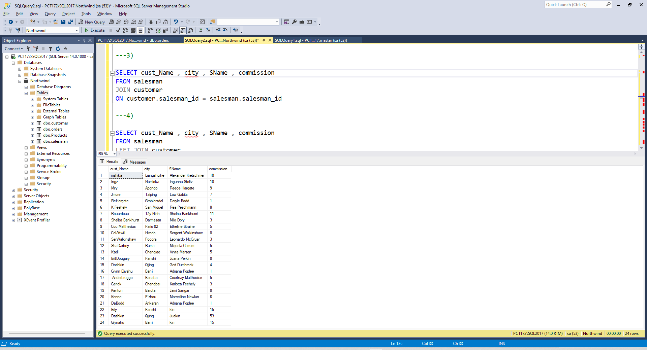

4. write a SQL query to find salespeople who received commissions of more than 12
percent from the company. Return Customer Name, customer city, Salesman,
commission.
SELECT cust_Name , city , SName , commission
FROM salesman
INNER JOIN customer
ON customer.salesman_id = salesman.salesman_id
WHERE Commission >12

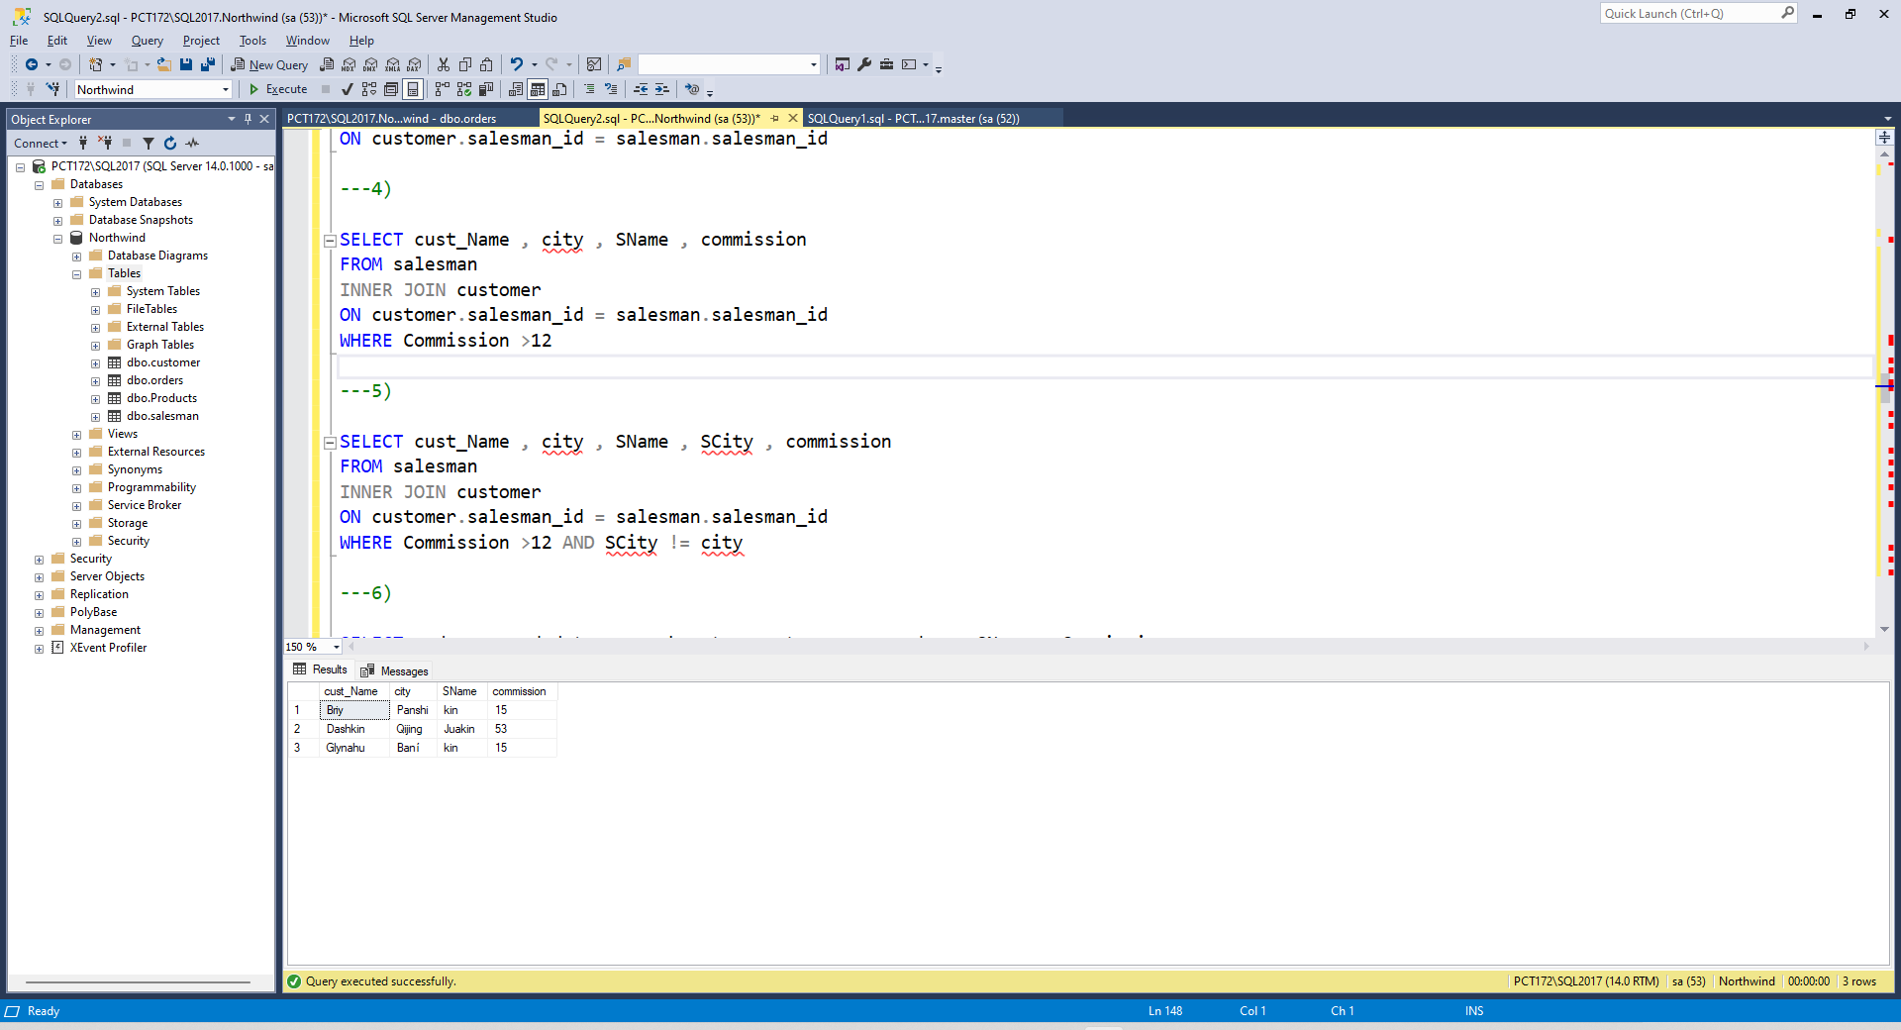
5. write a SQL query to locate those salespeople who do not live in the same city where their customers live and have received a commission of more than 12% from the company. Return Customer Name, customer city, Salesman, salesman city, commission

SELECT cust_Name , city , SName , SCity , commission
FROM salesman
INNER JOIN customer
ON customer.salesman_id = salesman.salesman_id
WHERE Commission >12 AND SCity != city

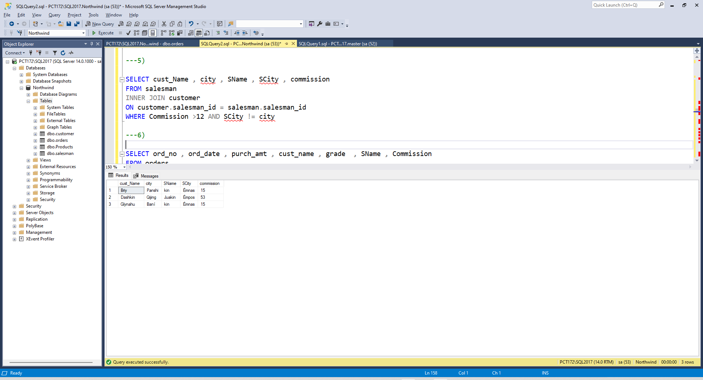
6. write a SQL query to find the details of an order. Return ord_no, ord_date,
purch_amt, Customer Name, grade, Salesman, commission
SELECT ord_no , ord_date , purch_amt , cust_name , grade , SName , Commission
FROM orders
INNER JOIN customer
ON orders.customer_id = customer.customer_id
INNER JOIN salesman
ON orders.salesman_id = salesman.salesman_id
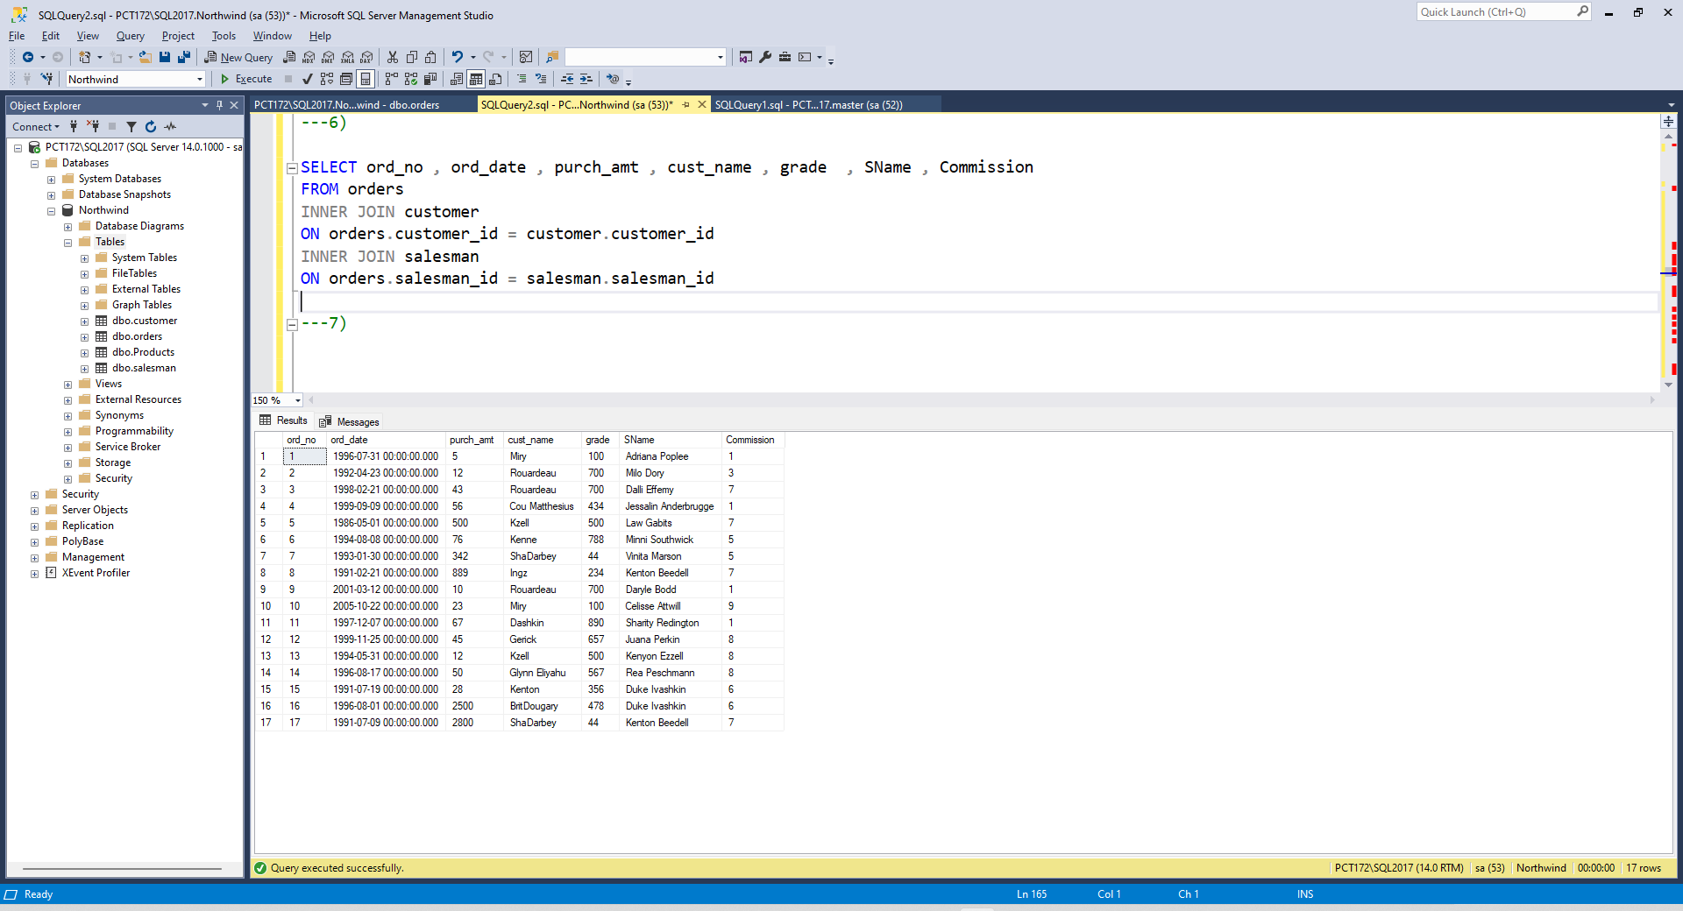
7. Write a SQL statement to join the tables salesman, customer and orders so that the same column of each table appears once and only the relational rows are returned.
SELECT * FROM salesman
NATURAL JOIN customer
NATURAL JOIN orders

8. write a SQL query to display the customer name, customer city, grade, salesman,salesman city. The results should be sorted by ascending customer_id.
SELECT cust_Name , city ,grade, SName , SCity
FROM customer
INNER JOIN salesman
ON customer.salesman_id = salesman.salesman_id

ORDER BY customer_id ASC

9. write a SQL query to find those customers with a grade less than 300. Return
cust_name, customer city, grade, Salesman, salesmancity. The result should be
ordered by ascending customer_id.
SELECT cust_Name , city ,grade, SName , SCity
FROM customer
INNER JOIN salesman
ON customer.salesman_id = salesman.salesman_id
WHERE grade < 300
ORDER BY customer_id ASC
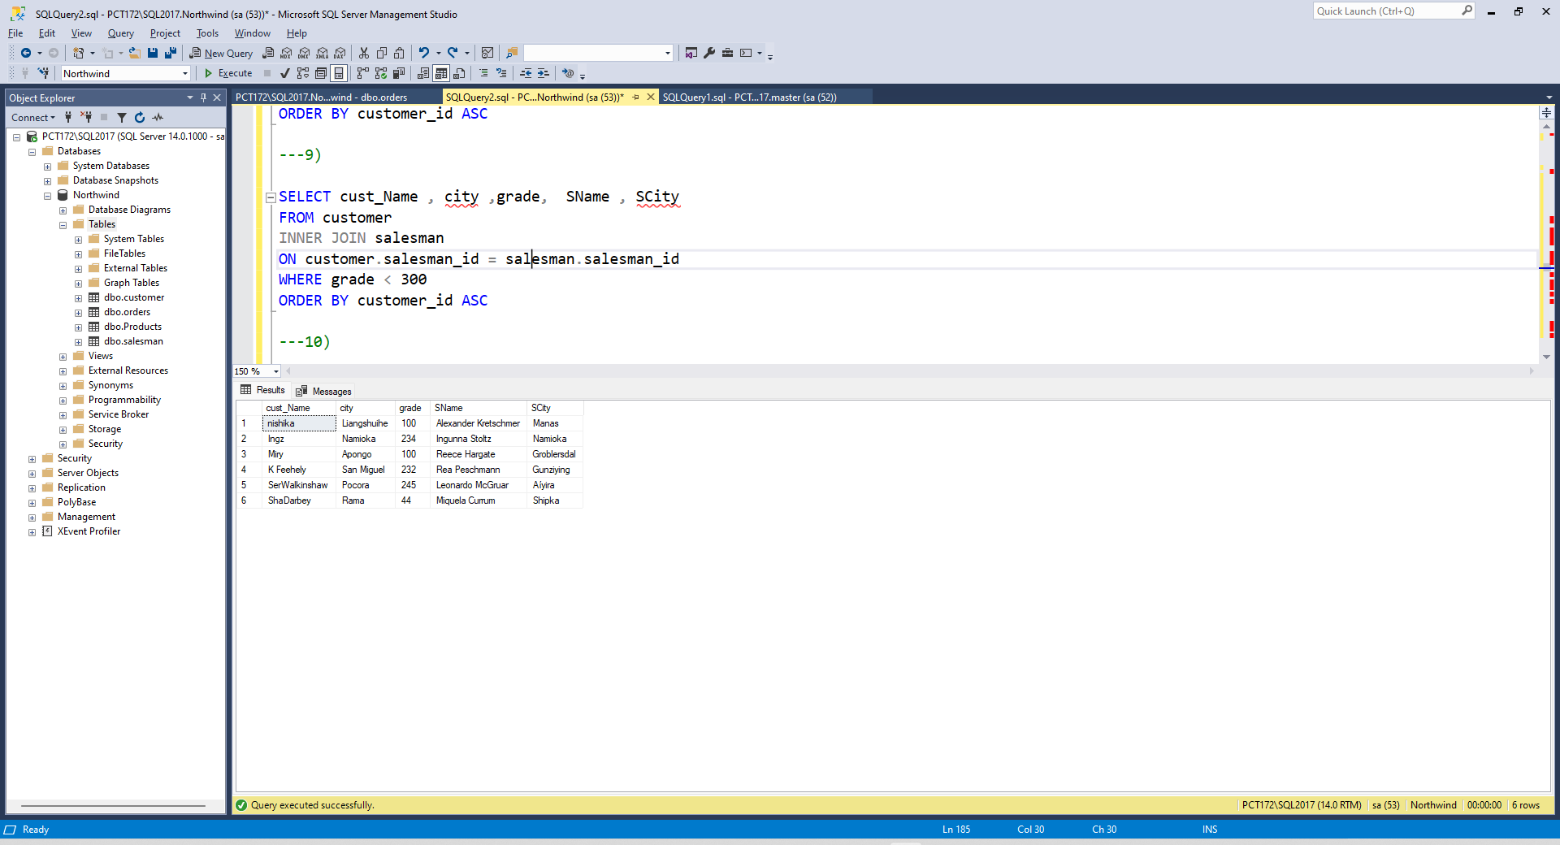
10. Write a SQL statement to make a report with customer name, city, order number,
order date, and order amount in ascending order according to the order date to
determine whether any of the existing customers have placed an order or not
SELECT cust_Name , city ,ord_no , ord_date , purch_amt
FROM customer
INNER JOIN orders
ON customer.customer_id = orders.customer_id
ORDER BY ord_date ASC
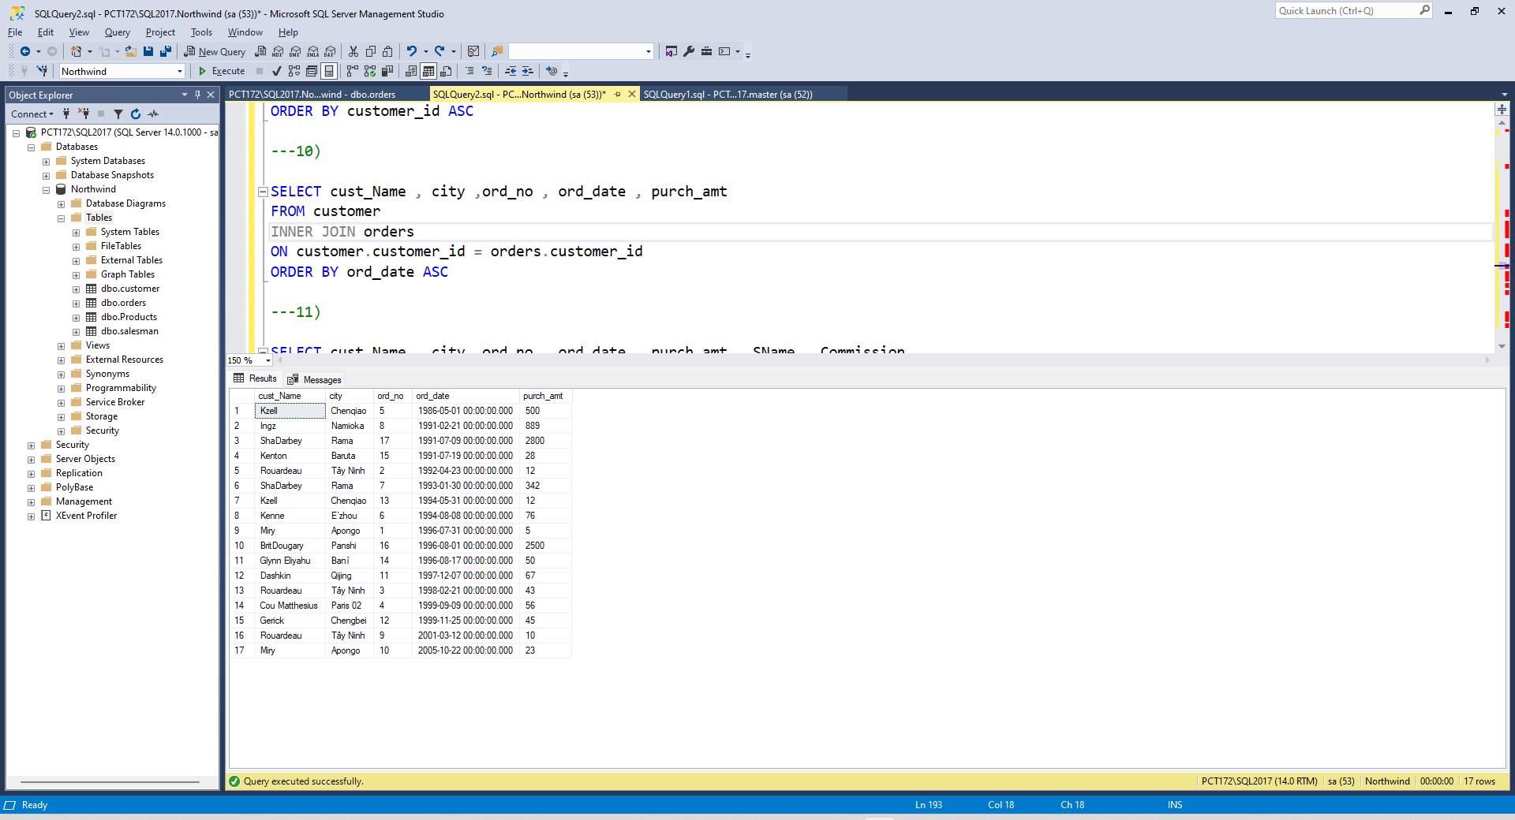
11. Write a SQL statement to generate a report with customer name, city, order number,order date, order amount, salesperson name, and commission to determine if any of the existing customers have not placed orders or if they have placed orders through their salesman or by themselves
SELECT cust_Name , city ,ord_no , ord_date , purch_amt , SName , Commission
FROM customer
LEFT OUTER JOIN orders
ON customer.customer_id = orders.customer_id
LEFT OUTER JOIN salesman
ON orders.salesman_id = salesman.salesman_id
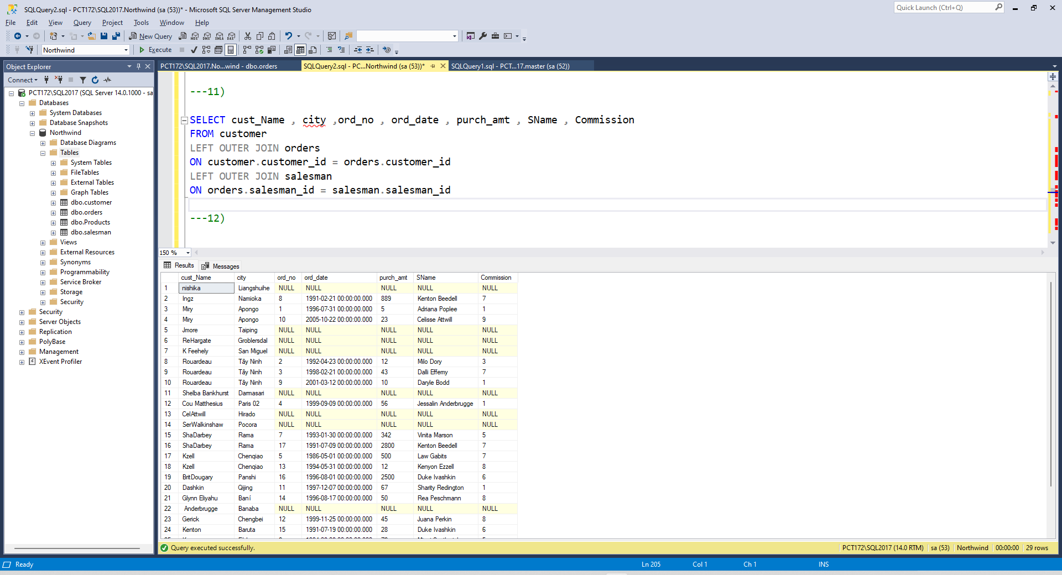
12. Write a SQL statement to generate a list in ascending order of salespersons who work either for one or more customers or have not yet joined any of the customers
SELECT SName, SCity , cust_Name ,city
FROM salesman
LEFT OUTER JOIN customer
ON customer.salesman_id= salesman.salesman_id
ORDER BY salesman.salesman_id
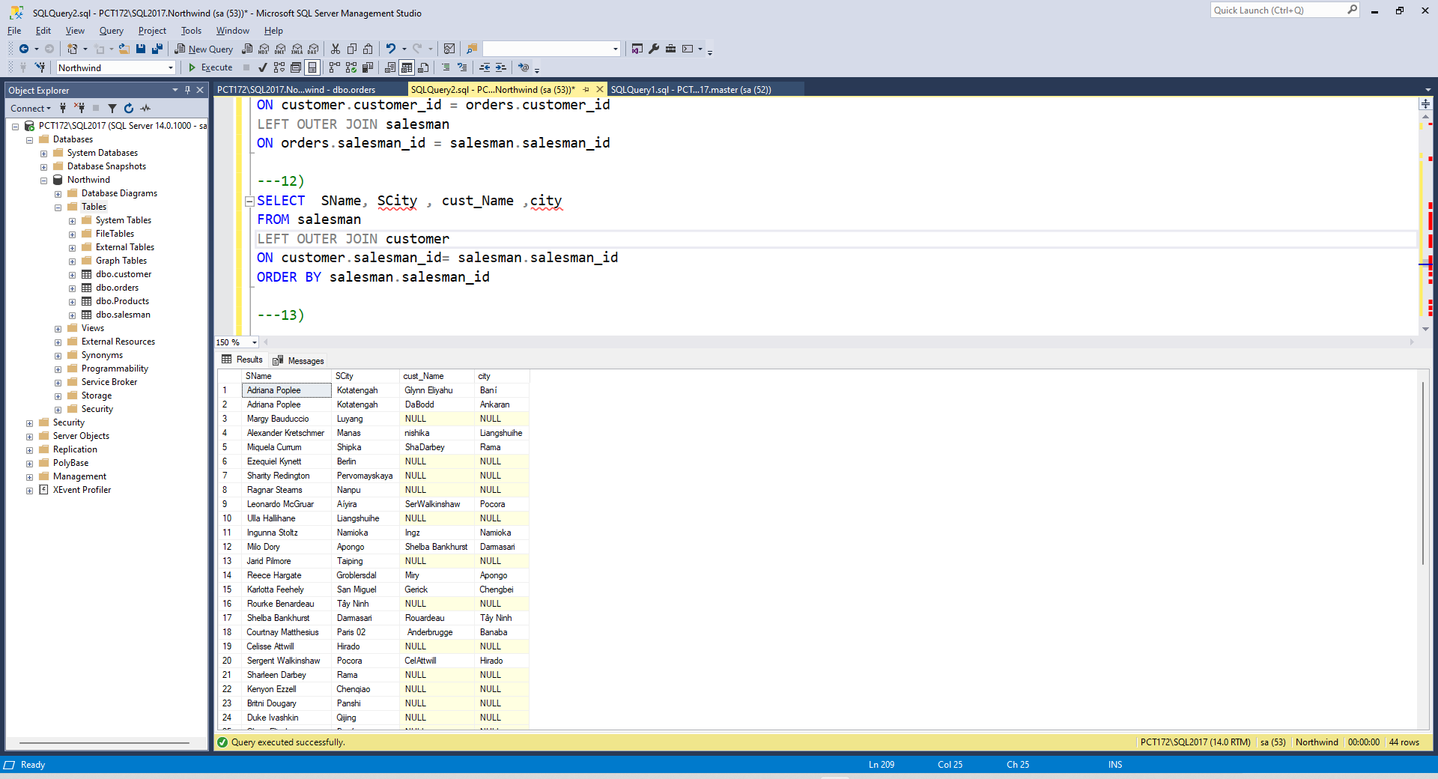
13. write a SQL query to list all salespersons along with customer name, city, grade, order number, date, and amount.
SELECT SName ,cust_Name , city , grade , ord_no , ord_date , purch_amt
FROM salesman
LEFT OUTER JOIN customer
ON salesman.salesman_id =customer.salesman_id
LEFT OUTER JOIN orders
ON orders.salesman_id = salesman.salesman_id
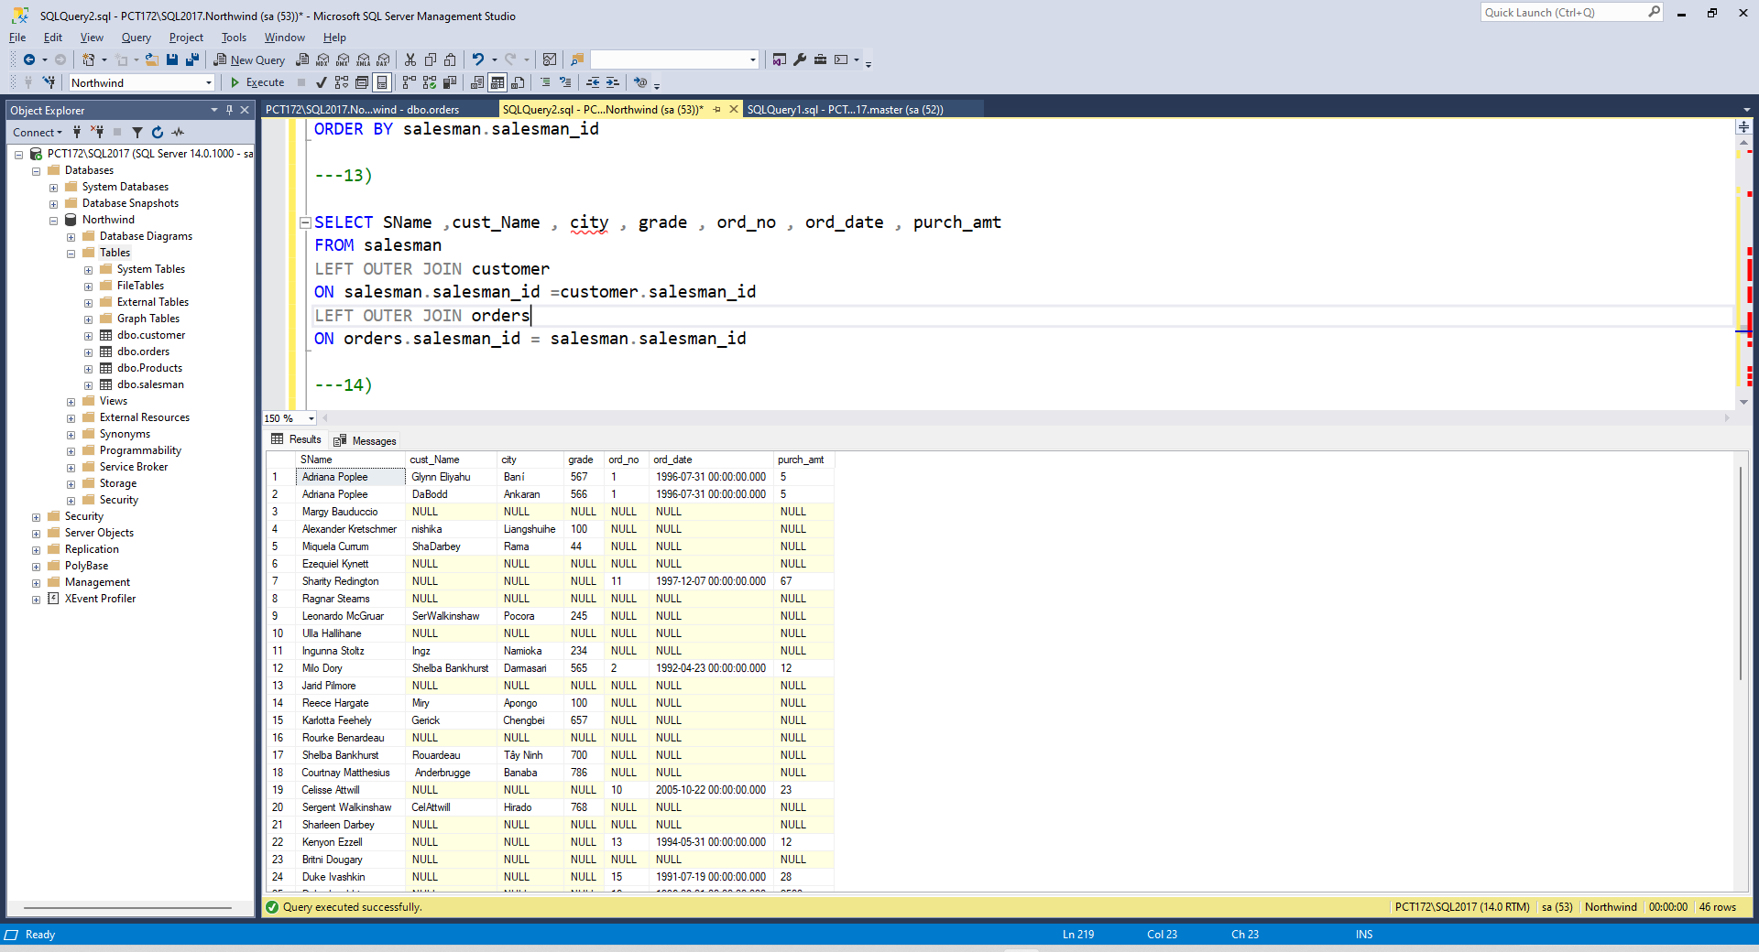
14. Write a SQL statement to make a list for the salesmen who either work for one or more customers or yet to join any of the customers. The customer may have placed, either one or more orders on or above order amount 2000 and must have a grade, or he may not have placed any order to the associated supplier.
SELECT cust_Name,city,grade, SName , ord_no, ord_date, purch_amt
FROM customer
RIGHT OUTER JOIN salesman
ON customer.salesman_id=salesman.salesman_id
LEFT OUTER JOIN orders
ON orders.customer_id=customer.customer_id
WHERE purch_amt>=2000
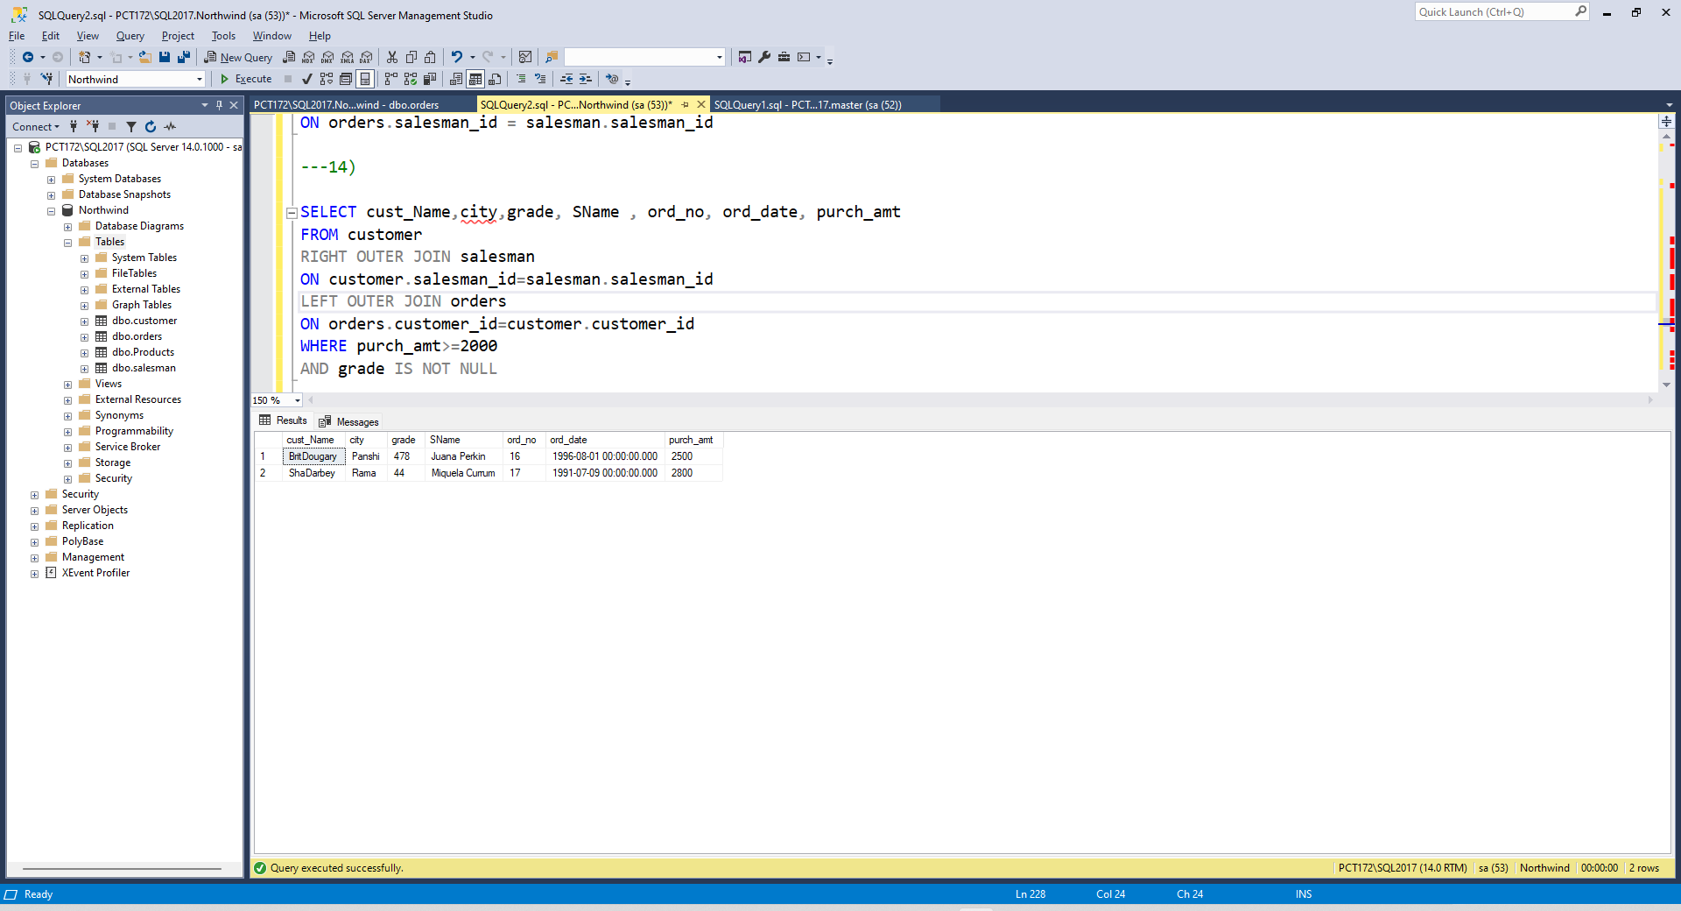
AND grade IS NOT NULL

15. Write a SQL statement to generate a list of all the salesmen who either work for one or more customers or have yet to join any of them. The customer may have placed one or more orders at or above order amount 2000, and must have a grade, or he may not have placed any orders to the associated supplier.
SELECT cust_Name,city,grade, SName , ord_no, ord_date, purch_amt
FROM customer
RIGHT OUTER JOIN salesman
ON customer.salesman_id=salesman.salesman_id
LEFT OUTER JOIN orders
ON orders.customer_id=customer.customer_id
WHERE purch_amt>=2000
AND grade IS NOT NULL

16. Write a SQL statement to generate a report with the customer name, city, order no.order date, purchase amount for only those customers on the list who must have a grade and placed one or more orders or which order(s) have been placed by the customer who neither is on the list nor has a grade.
SELECT cust_Name,city, ord_no, ord_date, purch_amt
FROM customer
FULL OUTER JOIN orders
ON orders.customer_id=customer.customer_id
WHERE grade IS NOT NULL

17. Write a SQL query to combine each row of the salesman table with each row of the customer table
SELECT * FROM salesman
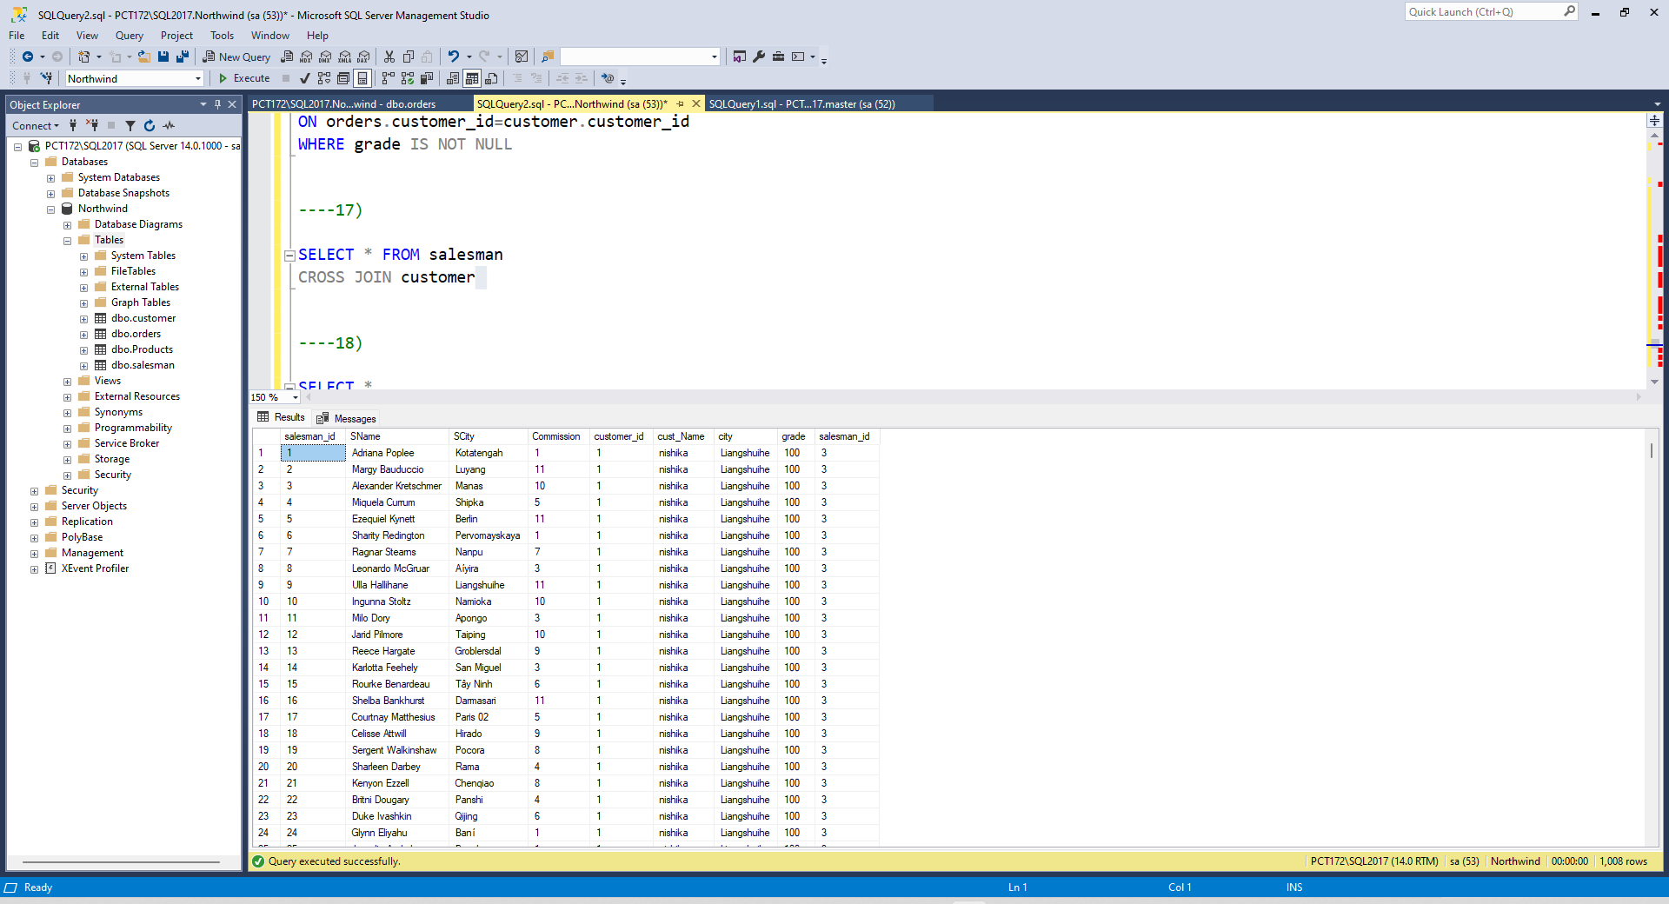
CROSS JOIN customer

18. Write a SQL statement to create a Cartesian product between salesperson and customer, i.e. each salesperson will appear for all customers and vice versa for that salesperson who belongs to that city
SELECT *
FROM salesman
CROSS JOIN customer
WHERE SCity = city
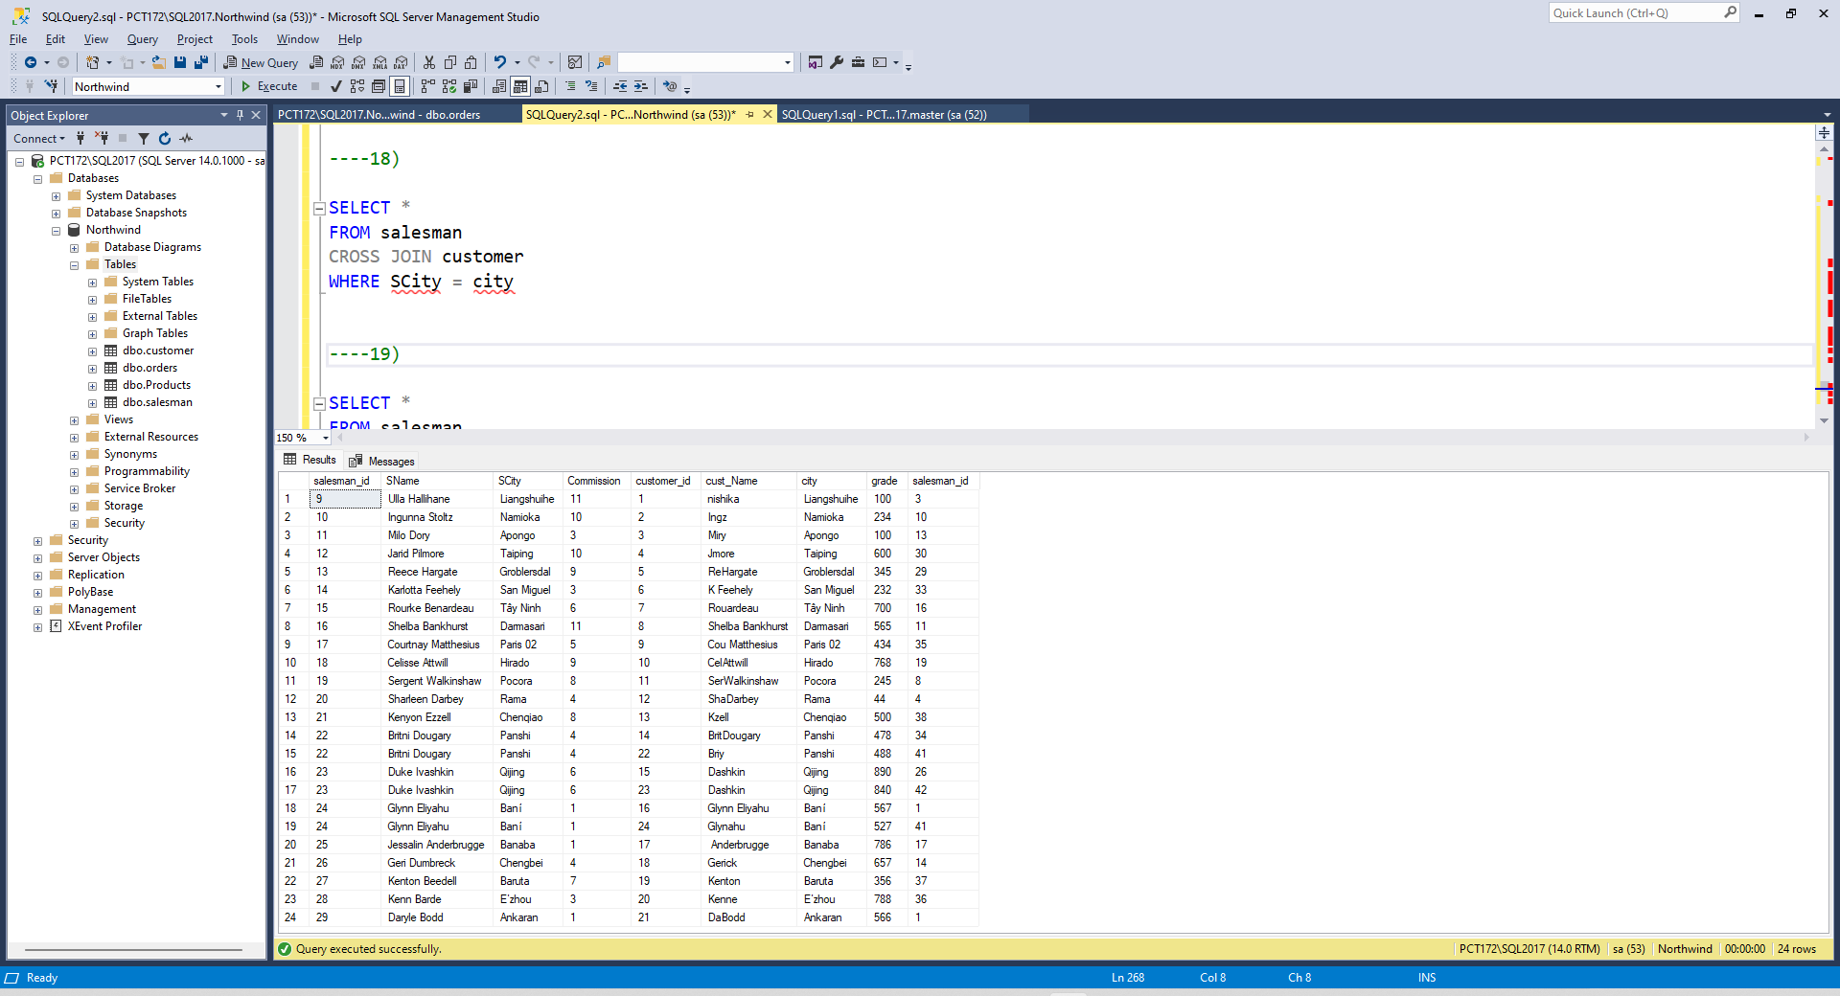
19. Write a SQL statement to create a Cartesian product between salesperson and
customer, i.e. each salesperson will appear for every customer and vice versa for
those salesmen who belong to a city and customers who require a grade
SELECT *
FROM salesman
CROSS JOIN customer
WHERE SCity = city
AND grade IS NOT NULL
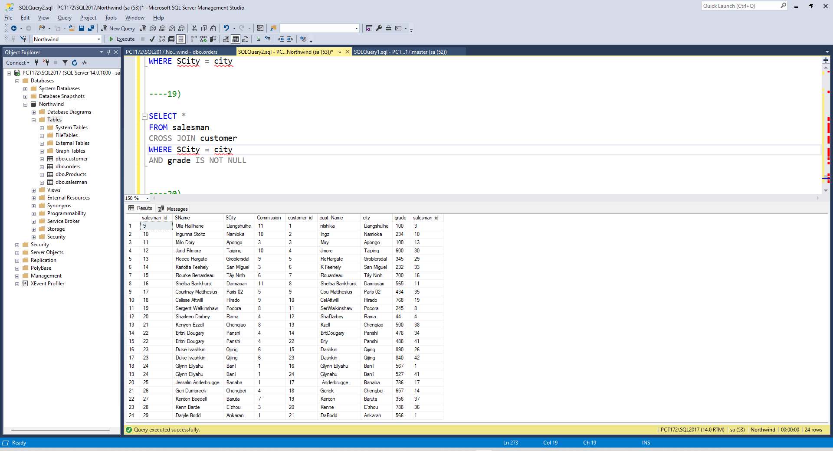
20. Write a SQL statement to make a Cartesian product between salesman and
customer i.e. each salesman will appear for all customers and vice versa for those
salesmen who must belong to a city which is not the same as his customer and the
customers should have their own grade
SELECT *
FROM salesman
CROSS JOIN customer
WHERE SCity != city
AND grade IS NOT NULL
